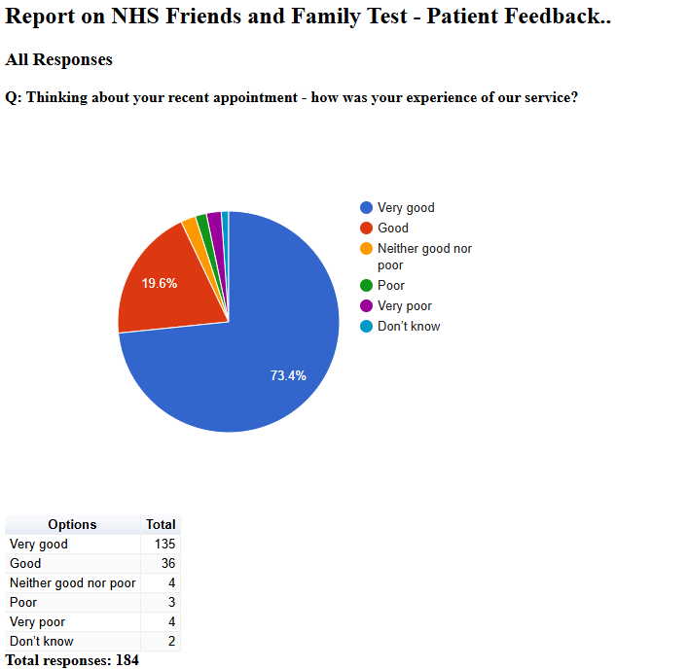

Friends and Family Admin

NHS Friends and Family Test - Patient Feedback

September 2024

All Responses

Q: Please tell us about anything that we could do better:
Free text question. There were 63 responses:
2024-09-02 13:10:14 View entire form
Nothing you are all doing a sterling job ! Had an appointment today with Nurse Rosie and totally blown away by her care, knowledge and empathy shown towards me ! Keep up the good work all of you it is appreciated
2024-09-05 17:02:50 View entire form
Poor service
2024-09-06 10:14:56 View entire form
Was cancelled on the day as I could not come in earlier
2024-09-10 10:24:03 View entire form
Don't insult patients
2024-09-10 10:48:22 View entire form
the text i received reminding me of my appointment contradicted the information i was given when i arranged the appointment (i was told it would be by telephone but the sms said it was at the lanes), so i needed to make a further call to check but my experience and service overall was good in my view.
2024-09-10 10:49:05 View entire form
I thought the Doctor was really engaging with my daughter and made her feel less anxious about the appointment. She was kind, had such a lovely temperament and was thorough and we felt listened to. A really positive experience
2024-09-10 13:01:37 View entire form
I was advised I needed calpol, but I havn't received the prescription yet.
2024-09-10 13:10:25 View entire form
Dr Wright is a brilliant doctor who listens very well so nothing to tell you this time
2024-09-10 13:18:38 View entire form
Answer calls more speedily. All you have is a recorded message about how busy you are. You give the option to be called back without losing place in queue. I have tried this twice and never been called back. Please delete this option from your message.
2024-09-10 13:24:19 View entire form
Nothing.
2024-09-10 14:06:28 View entire form
Service was efficient, staff were polite and professional.
2024-09-10 15:13:04 View entire form
The doctor I saw was caring and empathetic. I hope to see her again in the future.
2024-09-10 15:57:33 View entire form
Nothing
2024-09-10 17:56:38 View entire form
I was told to stop my hrt, because of bleeding and had to argue a little bit against it.... although a phonecall later in the day confirmed I could continue, with a continuous progesterone routine, I would have preferred to see someone who specialises in hrt
2024-09-11 07:35:02 View entire form
As a wheelchair user, I found it he ramp useful but it was difficult entering the building.
2024-09-11 08:04:38 View entire form
Answer the phones would be a great start, have face to face appointments without having to wait forever
2024-09-11 08:48:24 View entire form
No thing
2024-09-11 13:07:07 View entire form
First of all the GP Dr Jardoon who saw me was absolutely brilliant. She really listened and was very proactive which I appreciated. This is something I have not experienced for many years. My only complaint not really a complaint but improvements could be made in the answering of phone calls which takes a l o n g time. The reception has improved partly I guess by more experienced people answering phone which is more reassuring. Overall my experience of this practice is totally opposite to my past experience before I moved to Vernon Street. I can only hope this level of treatment can be sustained. Thank you for your care so far.
2024-09-12 06:56:46 View entire form
All ok
2024-09-12 19:10:02 View entire form
Improve the appointment system and the time it takes to get through.
2024-09-17 04:26:36 View entire form
You are just good
2024-09-17 18:35:53 View entire form
Early follow up on the out come of the appointment.
2024-09-18 13:30:22 View entire form
Shorter waiting times on the phone
2024-09-20 14:28:31 View entire form
Nothing, I was very satisfied with the surgery as a whole.
2024-09-21 11:02:00 View entire form
Nothing that I can think of
2024-09-25 16:31:09 View entire form
Nothing tbf, I was very happy with the treatment I received.
2024-09-27 11:18:34 View entire form
Tell your Doctor that you have a second problem, instead of making another appointment, I’ve been stopped from telling the Doctor about another illness
2024-09-27 11:33:25 View entire form
I can't understand how your still operating under covid rules.when you ring Dr wright still gives the recorded message from covid times.you don't have blood test becouse of covid rules.im sure your the only practice working under covid rules
2024-09-27 11:41:12 View entire form
Carry on with the professional care your team gives
2024-09-27 11:42:53 View entire form
Nothing the service was fantastic
2024-09-27 11:50:48 View entire form
I was lucky and able to get an appointment same day. The Dr I was lovey and able to put my mind at ease.
2024-09-27 11:53:31 View entire form
Can always improve
2024-09-27 11:55:54 View entire form
Nothing to do better about
2024-09-27 11:56:09 View entire form
Was fine thanks. Well looked after me.
2024-09-27 12:01:51 View entire form
Nothing, I was very satisfied with my consultation and treatment. Many thanks to you all n
2024-09-27 12:04:33 View entire form
I always receive excellent care for my health, thank you very much ♥️
2024-09-27 12:08:09 View entire form
My telephone appointment was booked for 20th September. I never received a call. I even called the surgery at 5pm and they told me I would be getting my appointment call on the same day, this did not go ahead. Very poor service!
2024-09-27 12:10:24 View entire form
Longer time for disabled patients - a 10 minute slot is short for a disabled person with communication and physical issues.
2024-09-27 12:15:50 View entire form
Keep on improving
2024-09-27 12:16:32 View entire form
On my last visit you couldn’t have done anything better
2024-09-27 12:47:30 View entire form
Get an appointment sooner rather than having to wait a week
2024-09-27 12:59:14 View entire form
Nothing
2024-09-27 13:14:52 View entire form
Cannot think of anything that could be better.
2024-09-27 13:27:44 View entire form
I am very happy with my doctors and the services they offer. I am very grateful to them all. The doctor I saw was very kind and helpful and all the reception and support staff are as well, thank you
2024-09-27 13:47:37 View entire form
It's not easy to get through
2024-09-27 14:37:04 View entire form
To see a doctor of my choice, every appointment. Thanks
2024-09-27 15:32:02 View entire form
All good
2024-09-27 16:14:02 View entire form
I was able to speak to the doctor about health issues and not feel I was being pushed out the door. Excellent service!
2024-09-27 16:42:06 View entire form
I was very impressed and satisfied with my visit so can’t think of anything to have made it better
2024-09-27 17:26:03 View entire form
The nurse was kind enough to phone me regarding my medication but unfortunately she was not very clear with her instructions so she had to phone again to explain which I appreciated .this is not necessarily a reflection on her because it was a complicated message I thought. Nevertheless she had a kind tone .
2024-09-27 17:36:54 View entire form
More slots available at Vernon street.
2024-09-27 21:13:21 View entire form
The Dr I saw was very nice, I didn't feel rushed, he listened and was thorough with his assessment. Thanks.
2024-09-28 04:05:22 View entire form
Everyone was very considerate as helpful
2024-09-28 09:36:19 View entire form
Doctors made promises they didn’t deliver
2024-09-29 10:17:28 View entire form
Request an appointment as I had a sinus infection, advised gp would phone me but no call by 4pm so I called back to get a message saying everyone was on training, I had a call the next day from a practitioner and advised that I gained appointment through 111 with the pharmacist who prescribed antibiotics, no apology !
2024-09-29 14:57:36 View entire form
My consultation was professional and friendly so cannot see how it could be improved.
2024-09-30 10:36:57 View entire form
No
2024-09-30 10:38:23 View entire form
Excellent
2024-09-30 10:42:40 View entire form
Potentially make the appointments slightly longer as I struggled to fit everything I had to say into the allocated time?
2024-09-30 11:03:01 View entire form
I just started filling this up but took me off? I'd already replied before this one as well. Saying I need messages of my health problems text or written ones I was trying to finish it but I was cut off? When I ticked the next box do you know what had happened?
2024-09-30 13:03:33 View entire form
All staff and doctors is good
2024-09-30 13:36:59 View entire form
It would b good if can an early appointment
2024-09-30 15:37:18 View entire form
No your good at what you do

