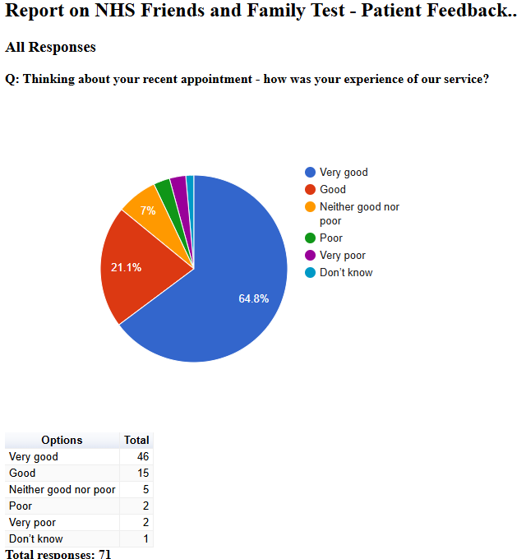

Friends and Family Admin

NHS Friends and Family Test - Patient Feedback

October 2024

All Responses

Q: Please tell us about anything that we could do better:
Free text question. There were 24 responses:
2024-10-01 12:57:18 View entire form
Very efficient experience, managed to get an appointment within 2 days.
2024-10-01 14:30:58 View entire form
The doctor was no help and I still have cough and breathlessness
2024-10-02 09:25:37 View entire form
Offer more options for appointments. The Doctors here are Great.
2024-10-02 19:30:52 View entire form
Good service
2024-10-03 14:16:29 View entire form
The whole experience was excellent, thank you
2024-10-03 19:21:18 View entire form
Better staff
2024-10-08 08:45:22 View entire form
Nothing on this occasion
2024-10-11 08:28:13 View entire form
Nothing!
2024-10-11 08:28:52 View entire form
Had a chest infection am had no way of getting into the surgery due to disability’s an no one to bring me in so they gave me a phone calls appointment an send me my prescription over to my pharmacy
2024-10-11 08:54:54 View entire form
Dr Sabir eas excellent
2024-10-11 09:21:54 View entire form
Well to start off , how about the appointment system you have ... covid has long gone and everyone is back to working normal ....but as for GPs you seem to be still in lockdown . To me and several others our GP practice has gone downhill . Everyone's needs have changed and I do take that on board ...I've worked in the NHS so I do try to be patient and not speak out of turn . But I felt this has to be said
2024-10-11 09:23:05 View entire form
It was a pleasant experience. The doctor was kind, patient & detailed, gave me a professional advice. Many thanks
2024-10-11 09:46:00 View entire form
You gave me an appontment then didn’t ring me for 7 days
2024-10-11 09:52:26 View entire form
Very friendly and prompt
2024-10-11 09:57:15 View entire form
All Excellent
2024-10-11 12:02:23 View entire form
Nothing needed.
2024-10-11 12:06:31 View entire form
I was wrongly diagnosed. I was told it was most likely a bite and I was tired due to anti istamines. I asked if it was shingles and told no. The following week I was seen by a Doctor at the walk in centre who diagnosed me with shingles. He said if I had come to Docs sooner they could have prescribed something to stop it developing further. I did but sadly it wasn't diagnosed. The result in my being very poorly and now permanently scarred on my head. Mr G
2024-10-11 12:37:51 View entire form
I'm assuming this is the appointment for the covid and flu jabs tather than the telephone appointment a few days before
2024-10-11 15:42:42 View entire form
I didn’t feel listened to, the doctor was mainly focusing on writing her notes.
2024-10-11 15:43:42 View entire form
Stressful to book on appointment but Dr Sabir was very efficient. Would prefer to be given an 1-2 hour time slot for call back. It creates anxiety waiting for the phone to ring.
2024-10-11 17:33:15 View entire form
Being able to book an appointment for the next day, rather than having to call on a day to see if there is any appointment available. Luckily I was able to attend but not everyone has the luxury of attending an appointment with 45 mins notice.
2024-10-13 00:59:38 View entire form
Need more appointments
2024-10-13 08:13:58 View entire form
I made appointment to see doctor because I was in agony with my haemoroids the Firdt receptionist refused me to see the doctor and referred me to a pharmacist waited hours fir the pharmacist and offered me advice on medication the chemist wasn't local to me, and said I would have to pay for it I'm disabled struggle to get out and struggling financially as it is to pay my bills the haemoroids were very large and I was struggling to go to the toilet and wipe my self without pain. Prescription offered on its own from chemist would not work I needed, eventually got through to a doctor phone consultation and when he saw how bad it was gave me suppositories and a cream and powder to help with constipation and I've had to do a stool sample for a cancer check also if it don't go down after this medication after 7 days a hospital referral. What I'm saying haemoroids can be very serious to a person's daily living which mine was and I felt like I was just on a list of you got piles not serious go to pharmacy. Like I say eventually after waiting hours then having to ring back to say I need to speak to a doctor I got a telephone consultation (I did emphasise to the receptionist I was in severe pain hadn't slept all over weekend and struggled to do the above.
2024-10-14 19:35:30 View entire form
Couldn't have done anything better. Excellent service. Was allowed to see the Doctor of my choice and the receptionist at both surgery's were extremely friendly and helpful. Thank you

