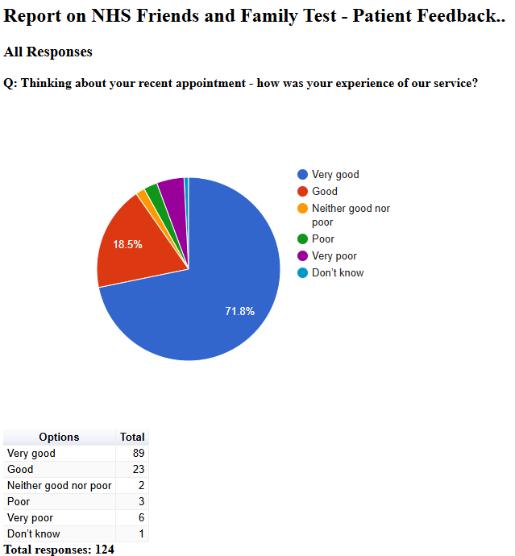

Friends and Family Admin

NHS Friends and Family Test - Patient Feedback

November 2024

All Responses

Q: Please tell us about anything that we could do better:
Free text question. There were 42 responses:
2024-11-12 12:10:58 View entire form
It is so hard to get a appointment with the doctors as the receptionist never want to give you a appointment.. I was told to go to a&e or ring 111 or walk in center as there was no appointments then once I had a go to say no I just want to see a doctor they booked me appointment
2024-11-12 12:14:58 View entire form
I asked to see a doctor and got a nurse who basically didn't give good advice. I was waiting over 20 mins before I was called in .
2024-11-12 12:24:18 View entire form
Have more time to deal with not just one issue
2024-11-12 12:29:02 View entire form
Dr. Sabir is a first class clinician. He listened to my problem and got me an immediate appointment with ENT at Derby Royal Hospital. An absolute five star service. Many thanks.
2024-11-12 13:52:52 View entire form
The doctor made me feel very comfortable, I’m a anxious person & im usually uncomfortable around others but he made me feel safe to speak honestly
2024-11-12 14:19:16 View entire form
Glad to get the doctor who isn't dismissive
2024-11-12 15:17:47 View entire form
Nothing excellent practice. Doctors,Nurses and receptionists are so kind and caring.
2024-11-12 17:14:27 View entire form
Really happy with the quality of professionalism from Dr Yousef. Receptionist on duty at that time was also really helpful.
2024-11-12 19:21:19 View entire form
Everything is good
2024-11-13 08:08:27 View entire form
Dr sanley/ Stanley interaction way was uncivilized & ill-mannered. He offers you to do this & do that where argumentative time really makes nobody comfortable Asked to be seen by alternative Dr later in week
2024-11-13 10:54:55 View entire form
Nothing really
2024-11-13 14:30:51 View entire form
I received a great understanding & advice:) Thank you very much
2024-11-14 08:18:00 View entire form
Nothing it really is good.
2024-11-19 12:53:14 View entire form
Receptionists at the front desk very unhelpful and dismissive
2024-11-19 13:10:52 View entire form
Dismissive, obstructive, prejudiced, out of date advice. Lyn bott
2024-11-19 13:12:51 View entire form
Needed to discuss issues with a doctor and the person I saw couldn't help with this
2024-11-19 13:17:40 View entire form
Everything is fine and your service is excellent. Thank you.
2024-11-19 13:24:33 View entire form
Nothing
2024-11-19 13:27:13 View entire form
Not happy at all
2024-11-19 13:28:43 View entire form
GP had the most amazing communication and interpersonal skills, sensitivity and warmth throughout my appointment. He has time to listen, empathise, ask questions and educate me as to my condition. Such A wonderful doctor
2024-11-19 13:36:16 View entire form
I felt listened and not rushed out of the door.
2024-11-19 13:39:09 View entire form
Ensure doctors practitioners listen to patients, have been ill chesty cough earache sore throats & reflux since june/July constantly. I am still in agony, but now on appropriate meds. And slowly feeling slightly better. But now terrified of lasting effects.
2024-11-19 13:42:44 View entire form
I thought Dr right was very helpful and made me understand everything and what didn't know which helped me greatly with myself she's was a lovely doctor very friendly person and feel like she's help me loads to my recovery
2024-11-19 14:47:59 View entire form
Dr yusuf is a great process that would always recommend
2024-11-19 14:52:17 View entire form
Appointment not on time, but Doctor era excellent Many Thanks
2024-11-19 14:52:38 View entire form
Appointment closer to my home,
2024-11-19 15:33:39 View entire form
Give more info on why changing medication
2024-11-19 17:33:53 View entire form
Try and adjust the manner of the staff to be less scolding for the circumstances that lead a patient to ask for an appoinment. I’ve been twice in the last month or so, and experienced the same feeling, that I am responsible for the condition I am in, and should seek over the counter products or services to resolve it. I specifically had a medication issue which I understand warrants a Dr review, but this didn’t happen dispute being told I should have asked for a double appointment and was then distanced from this review I experienced. Whereas I take accountability for some of the circumstances for my health, I have requested to see a Dr each time but seldom get this experience. I understand a triage element to appointment arrangments, but if the cost of seeing other healthcare staff is the feeling I shouldn’t have come in, then surely something is amiss in the surgery’s care provision. I think informing patients of who they are to see and if this can’t be a Dr then offering an informed choice? I don’t wish for a third instance of the staff I saw above, but don’t believe I have an option other than having to risk it should I need to cal again. I received a feedback request after then first appointment but chose not to report it as felt it may be a one off, but had this experience continue, which has left me reluctant to follow up in the future.which I feel I must share if I’m to hope for improvement.
2024-11-20 10:17:36 View entire form
I don't have any comments because u are doing well
2024-11-20 16:28:29 View entire form
To view and book gp appointments through systems online
2024-11-21 09:46:43 View entire form
More face to face contact with medical staff
2024-11-21 12:19:17 View entire form
Nothing at all.
2024-11-26 12:17:07 View entire form
Nothing excellent service as always
2024-11-26 12:18:12 View entire form
On this occasion everything ran very smoothly
2024-11-26 12:28:26 View entire form
Listen to our problems and try to help us
2024-11-26 12:38:35 View entire form
If we could call any times of day,to make appointment.
2024-11-26 12:42:09 View entire form
I was a little surprised to be asked why I needed a sicknote from the receptionist, I had already explained I was still not feeling well after seeing one of he surgery professionals the previous week. I had been told I needed to provide a sicknote by work. I was happy that on the 2 /3 occasion I called for an appointment I was seen. Within the hour and the call back service is good
2024-11-26 12:46:05 View entire form
I originally visited 2 weeks ago with a poorly chest. I had been coughing up green phlegm and was feverish & aching. The GP sent me away with antibiotics for an ear infection after I told her my ear hurt too however I have ongoing issues with my ear and have had 3 lots of surgery on it previously. On this appointment I felt quiet fobbed off like my chest wasn't and issues. 4 days later I visited the GP again with the same chest problem but now I also had diarrhea with blood. I was given antibiotics for a chest infection. 5 days later I rang to get an appointment as I still felt no better, if not worse and I had had some sharp chest pains. The receptionist was unhelpful and told me I couldn't have an appointment because I was already on antibiotics (I took the last one this day) I felt in such a low mood and became very upset on the phone. I felt no one was there to listen or help. I am a single mum of 3 and have no outside support. Being ill has caused me lots of guilty emotions. Iv not been able to go to work etc and I have been so low, almost suicidal. The receptionist response added to these already horrible feelings. 3 days later after the weekend I rang the GP to chase up my extended sick note as I needed to let my employer know what was happening. I also asked if I could drop a urine sample down to the surgery to be tested as alongside my poorly chest and loose stools I now had very yellow urine and tummy/back pain. I was told by the receptionist I could drop a sample into a pharmacy and they would dip test it. I drove to 3 different pharmacies but non would test my sample so I went to the surgery but they wouldn't test it either without and appointment. By this point I had lost all faith in my GP practice. I managed to get an appointment at the walk in centre that afternoon. The walk in centre doctor sent me straight to a&r with suspected pneumonia, she couldn't hear any air entry to my upper lobes. I spent most of lastnight in a&e, I was given an ECG, chest x-ray and bloods. I have now been given different antibiotics. During this last 2 weeks I feel a lot could have been avoided had the doctor I initially visited about my chest, listened to what I was saying.
2024-11-26 12:50:51 View entire form
Nothing everyone was very pleasant
2024-11-26 13:02:10 View entire form
Nothing
2024-11-26 13:03:49 View entire form
Would have been better to see a doctor
2024-11-28 02:53:49 View entire form
It took me 18 months to get an appointment

