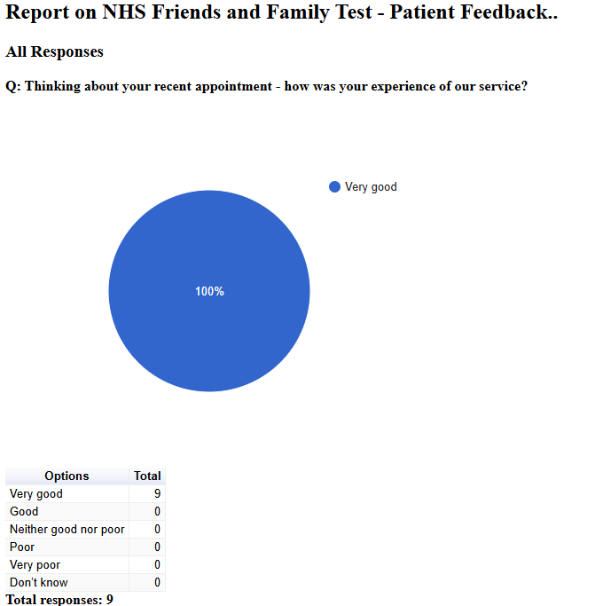

Friends and Family Admin

NHS Friends and Family Test - Patient Feedback

May 2025

NHS Friends and Family Test - Patient Feedback

All Responses

Q: Please tell us about anything that we could do better:
Free text question. There were 3 responses:
2025-05-01 00:28:48 View entire form
Happy with the service you provide.
2025-05-01 00:32:03 View entire form
Happy with the service you provide.
2025-05-01 07:31:18 View entire form
It would be better if possible to see the same doctor each time, though I know that this may be difficult.

