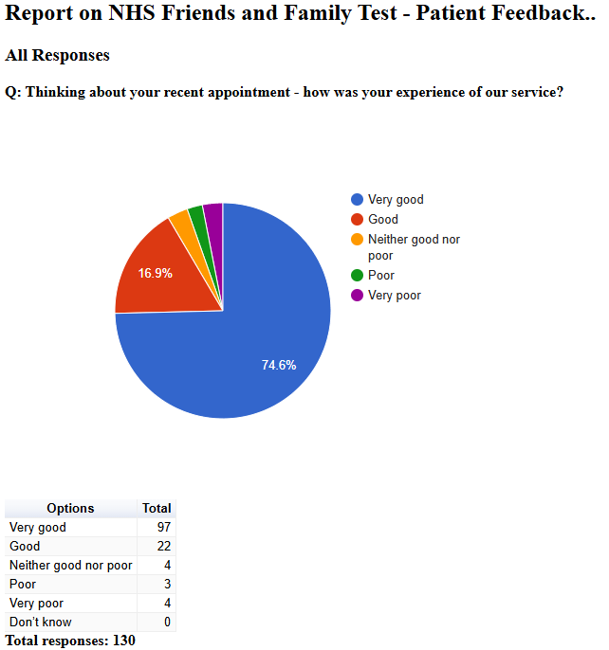

Friends and Family Admin

NHS Friends and Family Test - Patient Feedback

March 2025
2025-03-12 15:24:50 View entire form
Nothing, I arrived a few minutes late, traffic issues, and Dr Sabir added me on the end.
2025-03-12 15:41:41 View entire form
The practice is brilliant nothing to improve
2025-03-12 15:53:59 View entire form
This was my first appointment as a new patient at the surgery - From the friendly helpful receptionist,to being called on time for my appointment and the empathy and support I received during my consultation was first class , I truly feel that that nothing could have been any better-'my only regret is I haven't registered at the practice earlier
2025-03-12 15:57:21 View entire form
Friendly lady on reception helpful, happy of outcome of appointment.
2025-03-12 16:49:53 View entire form
I’m happy with everything I don’t think you need to change anything
2025-03-12 16:52:13 View entire form
I was unfortunately 12 mins late for my diabetes check up as I was stuck in awful traffic. I’d rearranged all my clients around my appointment and although it was a 30 min appointment (and I’ve had many in the past never lasting more than 10 mins) I was refused to be seen. I appreciate I was late, but I’ve waited well over 30 mins to be seen at the surgery before so it’s a real shame the policy seems extremely one sided. I just don’t feel like gp surgeries are really geared up for busy people with commitments. I even offered to have the blood tests done at the hospital and just do the rest of my appointment while I was there but this wasn’t allowed either.
2025-03-12 17:19:57 View entire form
None
2025-03-12 17:24:40 View entire form
Not keep wasting my time and telling me you can’t find out what is wrong with me! I need a diagnosis! My condition has been going on for years!
2025-03-12 17:27:54 View entire form
Approachable and professional
2025-03-12 17:30:05 View entire form
I had a really positive experience with my last GP appointment, I actually felt listened to for the first time in a while and the GP was proactive in trying to help me resolve a health issue that I have been struggling with for 8months now and I'm still waiting for a specialist ENT appointment for and I really appreciated the help and support as it's really rare for the GP to look at the person as a whole rather than one problem at a time when quite often a health condition causes more than one issue at a time.
2025-03-12 17:33:12 View entire form
When we have to put our Names etc on the Screen it doesn't tell you where exactly to sit down? So have to ask rhe receptionist.
2025-03-12 17:33:25 View entire form
Make more appointments available
2025-03-12 17:35:27 View entire form
Maybe discuss blood test results with the patient. I saw the GP who suggested I had tests but there was no follow up. I phoned for the results and that was that.
2025-03-12 17:45:47 View entire form
Please shorten the answerphone message
2025-03-12 17:48:35 View entire form
On this occasion my appointment with Mike Barnwell went very well . Could not have gone better . I find Mike very thorough very nice man .
2025-03-12 17:59:49 View entire form
No the doctor was verygood
2025-03-12 18:07:41 View entire form
Be prepared for the appointment with the patient's history and reason for the appointment. Offer a half decent pain management service by looking at the patient's history.
2025-03-12 18:08:45 View entire form
Easier way to book appointments, can be difficult to call first thing in the morning
2025-03-12 18:14:10 View entire form
Let me speak to my doctor or someone from the surgery, not a locum who cannot see my records and history
2025-03-12 18:30:19 View entire form
The service is excellent, not rushed, attentive and caring
2025-03-12 20:00:22 View entire form
Everything was excellent
2025-03-12 20:09:16 View entire form
Doctor and staff all good
2025-03-12 20:10:14 View entire form
Doctor and staff all very good an helpful
2025-03-12 20:38:55 View entire form
Everything is very good so we don't have any complaints
2025-03-12 20:39:34 View entire form
Nothing
2025-03-12 21:43:17 View entire form
Communication back in reply, can be a but delayed and varies as to how uts communicated
2025-03-13 08:20:51 View entire form
Excellent experience from phone contact to make appointment. GP listened to my concerns, was reassuring, clearly gave me information with a full summary at the end of the consultation. Contact made to arrange an appointment for a test made the sane day.
2025-03-13 09:09:28 View entire form
More appointments for people
2025-03-13 09:45:41 View entire form
Reception staff at the Lane's excellent
2025-03-13 14:38:38 View entire form
NA
2025-03-14 06:13:41 View entire form
Good to see the Doctor again I forget his name now but he is always good. Knows his stuff " I'm waiting for a letter from the Royal Derby hospital for an appointment with the hand and elbow nerv damaged Clinic.
2025-03-14 19:49:23 View entire form
More available appointments could be helpful otherwise cannot fault the service.
2025-03-14 21:11:01 View entire form
No problems
2025-03-16 10:29:20 View entire form

Stop doing telephone appointments unless absolutely necessary
2025-03-26 14:07:43 View entire form
If there’s translation
2025-03-26 14:10:27 View entire form
Couldn't do better
2025-03-26 14:11:52 View entire form
Telephone call from doctor
2025-03-26 14:59:44 View entire form
I didn't feel that the.doctor really looked closely at my skin problem and was too ready to state it was psoriasis.without considering other possibilities.
2025-03-26 15:28:12 View entire form
Nothing
2025-03-26 15:44:26 View entire form
You gave excellent service, so can't think of anything you could have done better.
2025-03-26 16:29:44 View entire form
Good if not have to wait 6 weeks for steroid injection when in pain
2025-03-26 17:09:36 View entire form
Nothing he was very nice and really approachable - understanding and answered all questions
2025-03-26 18:13:01 View entire form
The Doctor I spoke to could not have done any better in my opinion. He was the kindest man. I felt he genuinely cared about what I was saying. He then gave me a follow up call the following week. He listened at a time I needed it the most and when he is at his most stretched as a GP. Sadly, I didn’t catch his name but whoever he was, he was fabulous. As was the receptionist I initially spoke with. I am so grateful for the cancelled slot…. Thank you both so much!
2025-03-26 19:29:25 View entire form
it took me 3 days to get appointment once got to see doctor service was very good
2025-03-26 21:17:20 View entire form
Punctuality
2025-03-27 06:36:08 View entire form
I was able to get an appointment on the day. The doctor prescribed something that has made me better.
2025-03-27 11:00:17 View entire form
Cannot think of anything

