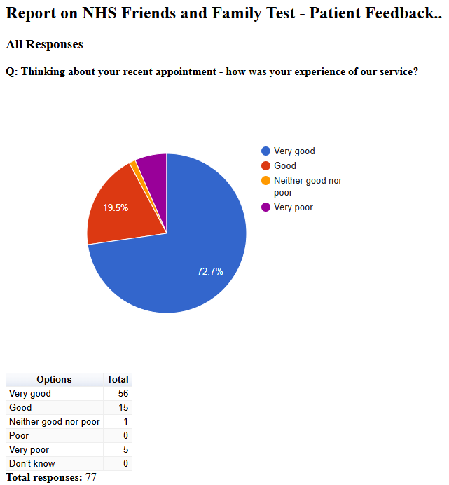

Friends and Family Admin

NHS Friends and Family Test - Patient Feedback

July 2024
2024-07-12 11:07:45 View entire form
Yes - have more people answering the phones(took 35 mins to get through - did use the 0 option to have someone call me back, but no-one did, so I had to call again - my boss is very impressed at the length of time I have been on the phone today!! Have more people to do the admin and leg work, rather than expecting the patient to do it?! Having just asked for a Health Check, I was told: You(The patient) come to the Surgery and get the Blood Form You (The Patient) then go online to another company and book in your appointment You (The Patient) then go to the Hospital, Clinic, Walk in Centre to have the Blood Test You (The Patient) then make an appointment to see your GP approximately 2 weeks after - if you are lucky enough to get through to make it, and then fingers crossed you can get an appointment for that far ahead! Can you see my point, The Patient does everything, which is probably ok if you don't work 12 hrs a day, and are a Carer for an Elderly Person, I really do not have the time to do all of the above, I just want a simple appointment at my GP's, whom I can go to - I won't be bothering!!! God forbid an elderly person has to go through all of that either. At my last GP's they would make the appointment with the Nurse and you turned up. They did everything else - no hassle, no calling different people and going to different places - NOT IMPRESSED
2024-07-14 07:26:11 View entire form
Nothing at the Present time
2024-07-16 10:49:07 View entire form
Everything was satisfactory
2024-07-16 10:51:17 View entire form
Keep the appointment or offer an alternative
2024-07-16 10:54:14 View entire form
Nothing needed as the appointment went very well.
2024-07-16 10:57:22 View entire form
Everything was fine, the feedback of results and advice were excellent
2024-07-16 11:06:08 View entire form
If we can get non-urgent appointments from submitting online form, if would be nice. It will save time and urgent slots.
2024-07-16 11:17:57 View entire form
Everything was brilliant apart from one thing. The appointment was made without warning and my surprise so to speak. It just happened to be inconvenient meaning I had to rearrange. So only a slight niggle but perhaps a bit more warning might be appreciated.
2024-07-16 11:32:41 View entire form
No problems
2024-07-16 11:46:31 View entire form
N/A
2024-07-16 13:34:26 View entire form
My appointment with the nurse was cancelled the evening before and not been rescheduled. No telephone calls received to date
2024-07-16 14:19:02 View entire form
Nothing
2024-07-16 14:29:57 View entire form
Very difficult to get through to make an appointment, when you do get through no appointments are available!!
2024-07-16 15:28:15 View entire form
To request online doctors appointments through systems online in advance would save less queuing on the phone
2024-07-16 17:40:12 View entire form
Nothing , every thing was fine
2024-07-16 23:45:33 View entire form
Explain everything well was understanding and polite
2024-07-18 11:13:49 View entire form
I have been dealing with Bell’s palsy since February, I kept going to A and E because of pain and symptoms. Last time I was at my GP, which is Vernon street medical centre, the doctor said I had to keep taking the same pills. I am experiencing unusual terrible conditions, why would I keep doing the same thing when it’s not working? I had to request for a scan, and that was when she thought to refer me. I can’t keep waiting for the maxillofacial department to reach me. I’ve just called the GP again this afternoon to complain that I haven’t been able to get through to the maxillofacial department and I was told there is nothing the GP can do. If the GP can’t reach them, how am I supposed to? Is it until I end up dead?
2024-07-19 08:45:56 View entire form
Every thing is fine.
2024-07-23 12:34:58 View entire form

I would like to submit a compliment to the Trainee Gp i visited at the surgery yesterday 22/07/2024 at 2.30PM. My name is Natalie Montroy and i wish for this to be placed in the compliments file. Dr Freya Doswell I believe was the lady who i saw and I am extremely happy with the outcome of this visit. I felt that she fully listened to the concerns that I have regards to my health and took into consideration previous medical history. A thorough examination was given and i did not at all feel as though i was rushed in the appointment. Dr Doswell treated me with Dignity and respect and had a very calming nature, which supported me to feel relaxed throughout the appointment. I asked reception if Freya would be staying on at the surgery as this was one of the better visits that i have had with this surgery. All the visits are very good, with all Gps at the surgery very thorough however this appointment stood out to me enough that I have completed a compliment that i believe is very much deserved. (I would like for this comment to be made public, however if you wouldn't mind removing my name and appointment details for publication - this was added so that the correct Dr could be identified - thankyou :-)
2024-07-26 11:37:47 View entire form
I have recently had a new blood result done privately for the CA125 antigen , done on 19th July ,however , I would like an appointment to bring in my blood test results to discuss this with either a Doctor or a Nurse . I was offered an appointment at the Lanes but I would prefer to have an appointment at Vernon Street as this a walking distance from my home .
2024-07-26 11:47:04 View entire form
Receptionist is very rude and uninterested in helping with queries, urgent matters. Discussion with GP revealed that symptoms discussed and reported to my first GP appt at the Lanes surgery hadn’t been recorded. I still have pain and rashes around the liver / gall bladder region that have still not been answered. I feel absolutely let down by the NHS service, and being a veteran soldier, does not provide the medical services i was told i could expect from being a veteran.
2024-07-26 11:48:54 View entire form
Try and shorten the phone queues ie waiting to get through
2024-07-26 11:50:46 View entire form
Thanks for all your help. Attending hospital within 10 days after surgery appointment
2024-07-26 12:37:25 View entire form
Service was great Dr. Doswell was thorough and they left feeling satisfied. Thank you. Always get brilliant service from both the Lanes and Vernon St. Professional but friendly team
2024-07-26 13:38:43 View entire form
Have more appointments to book in advance rather than having to call at 8.30 in the morning, which isn’t always possible due to work or times of walking the school run.
2024-07-26 17:21:15 View entire form
Nothing
2024-07-28 02:42:55 View entire form
Service was ok

