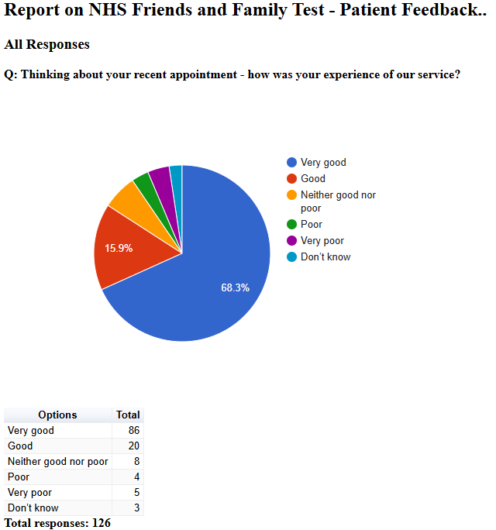

Friends and Family Admin

NHS Friends and Family Test - Patient Feedback

January 2025
2025-01-02 13:36:02 View entire form
Poor response to online message from one ANP, did not answer my question so I then had to contact the surgery again the following day. The other ANP then prescribed me a medication that could negatively interact with my regular medication. Would not reccomend the ANP's based on these interactions.
2025-01-07 10:53:55 View entire form
Not ringing up at 8 30 to go on a list for injection on knee 8 30 is for appointments receptionist adamant must ring 8 30
2025-01-07 10:55:09 View entire form
Times just lately have been poor appointments starting. But just frustrating for patients
2025-01-07 11:11:55 View entire form
Nothing tbh , phoned for an appointment and got one the same day . Thankyou
2025-01-07 11:12:13 View entire form
I’m happy how you run your surgery
2025-01-07 11:18:25 View entire form
In present circumstances everything is done well
2025-01-07 11:25:28 View entire form
Friendly professional and on time. Encouraging encounter
2025-01-07 12:40:13 View entire form
U sure why I need to go to dentist for an ear pain
2025-01-07 13:57:10 View entire form
Catharine could actually see someone before condemning them or forcing them to work under extreme pain. She doesn’t even know me, hasn’t met me but says I’m fit to work. Someone should actually take time and check my history out then sack her
2025-01-07 20:10:25 View entire form
No, it was all good thank you
2025-01-08 08:18:45 View entire form
My experience was very positive. I was seen quickly and efficiently at the service and was able to get an appointment for my ex rays almost immediately. I am very pleased with the service at Vernon Street.
2025-01-08 09:01:47 View entire form
Nothing needed, everything went perfectly
2025-01-08 10:04:15 View entire form
All good
2025-01-08 19:14:07 View entire form
Nothing better
2025-01-10 06:47:35 View entire form
Asked to see a doctor and was happy they could provide an appointment on the same day, but ended up with a nurse practitioner who didn’t seem to listen to me and in my opinion wasted the appointment by sending g Me for a blood test to confirm something that had already been confirmed. I wasn’t advised of this before attending surgery. If I had known I would have refused and requested a doctor.
2025-01-11 18:25:09 View entire form
Receptionist very good, very helpful. Doctor terrible, I told him I thought I had ear infection and a water infection he asked me which I thought was the worse one and he would treat the one i chose. He asked me if I had a temperature instead of him taking it himself. I have been with this doctors most of my life and have never known the waiting room to be so empty, after the message on the phone saying there is high demand at the present. I have previously gave the surgery 5 star reviews, bit I would not recommend the surgery to anyone now. Sorry for this review but I think you really need to get your house in order. I have had to go to boots to get treatment for the water infection, where the chemist was more helpful than my GP.
2025-01-13 11:52:33 View entire form
Receptionist was very rude and unhelpful. She essentially laughed at me whilst I was trying to arrange prescription milk for my 3 month old. I’ve never been so appalled by someone who works for an NHS service. Every single time we call the surgery we have to listen to the message about how we need to be kind and respectful to the staff. Certain staff would do well to pass that back to the people calling. I’ve been with the surgery years and I’ve never had a problem but last week the one lady I spoke to was awful. Other members of staff did do their very best to get what had been promised for my child which I’m very grateful for !
2025-01-13 17:29:01 View entire form
Nothing to change
2025-01-13 17:34:12 View entire form
Cannot think of anything that could be done better
2025-01-13 17:35:29 View entire form
I am still yet to be contacted by the surgery department. No visit to the hospital yet.
2025-01-13 17:44:08 View entire form
Being able to book an appointment via email/online. Also told that the allocated time slot is 10mins before the appointment.
2025-01-13 17:48:05 View entire form
More appointment slots would be great.
2025-01-13 17:52:35 View entire form
All of my. Recent appointments have taken time to happen can all patients be made to go in at their appointment time?
2025-01-13 17:54:43 View entire form
It is alright As it is
2025-01-13 17:56:26 View entire form
I didn’t have an appointment I have no idea why they keep saying I have
2025-01-13 17:58:19 View entire form
To maybe improve by being able to book appointments on line
2025-01-13 18:00:53 View entire form
Dr Appointment was on time and support was excellent. Well done. Please maintain the standard of service
2025-01-13 18:02:30 View entire form
The person I saw was quite dismissive and clearly did not want to be there.
2025-01-13 18:44:39 View entire form
Was given a sputem pot with no paper work, it was not excepted, and I have a chest infection.
2025-01-13 19:00:03 View entire form
The GP acted very quickly & professionally I was seen immediately with regards to my condition# the time..I'm so grateful. Thankyou
2025-01-14 06:44:27 View entire form
NOTHING, THE SERVICE YOU PROVIDED ME WITH WAS FIRST CLASS!!
2025-01-14 09:18:53 View entire form
More appointments at The Lanes.
2025-01-14 10:22:04 View entire form
Excellent
2025-01-15 16:35:34 View entire form
Can really point a fault
2025-01-16 10:24:00 View entire form
The doctor was good very reassuring .first class .excellent
2025-01-17 10:34:12 View entire form
Online appointment booking would be easier and apparently according to the government policy you should be offering this anyway
2025-01-21 09:27:36 View entire form
Nothing better but just want to say the nurses are so lovely especially since I was so nervous they really made me feel comfortable
2025-01-21 09:30:32 View entire form
Nothing
2025-01-21 09:40:34 View entire form
Better access for wheelchair users at the Lanes practise. We found it very difficult to get in and out of the doors
2025-01-21 09:42:12 View entire form
Speak with kindness, make the patient feel listened to. You may ne the ONLY person that patient has spoken to for days.
2025-01-21 09:43:51 View entire form
Polite very good DISCUSSION.
2025-01-21 09:44:13 View entire form
be clearerasro which surgery appt is at .I usually go to Lanes but my appt was made at Vernon St.
2025-01-21 09:45:50 View entire form
Actually send these when I’ve had an appointment
2025-01-21 09:48:06 View entire form
I could not get the help I needed
2025-01-21 10:40:24 View entire form
Giving early appointment
2025-01-21 11:19:36 View entire form
More pre-bookable appointments for routine follow-ups would be appreciated
2025-01-21 11:26:13 View entire form
All area of your services is just top notch. Please keep it up
2025-01-21 12:08:12 View entire form
My Dr seemed disinterested and after I told him my symptoms he said "what do you want me to do about it" that was surprising. I want you to do your job? Advise me. Treat me. Find out why I'm having symptoms. Come up with theories. Not dismissal. Any suggestions will do.
2025-01-21 23:36:43 View entire form
Bedside manner needs work
2025-01-22 14:12:28 View entire form
Looking through me txting saw this... I'm not sure with doctors how feel with the place, Had blood results supose to ring me but they did 5mins early was ready take the call 3.10pm so parked up, look at unknown phone , just depends who rings who knows about unknown number.. So l rang back straight way expecting get the nurse but once again waited 10mins no ring back, so expecting me to arrange for another phone call, can't improve when miss call or anything could email results what to do next. At the time was rushing round for me dad from one hospital to another, if hadn't rang up say might be little late, would of landed littlelover doctors lane medical as said in my txt message.
2025-01-22 15:35:02 View entire form
To have a medical issue responded to by a non-qualified assistant manager is totally unacceptable.
2025-01-22 16:45:26 View entire form
Not keen on the “ ring up at 8-30’

