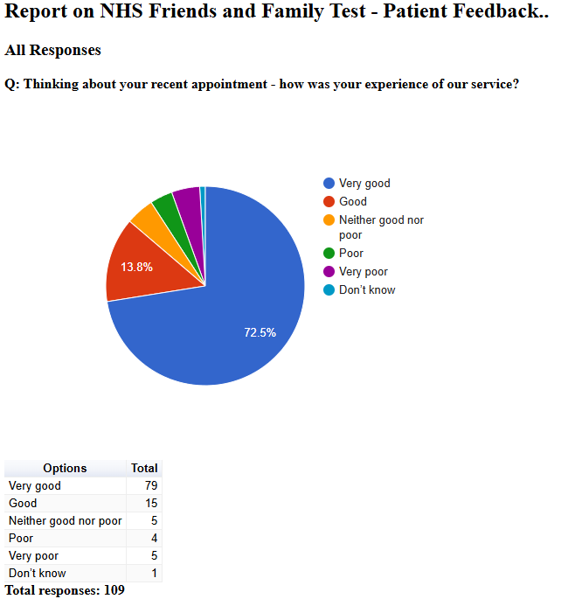

Friends and Family Admin

NHS Friends and Family Test - Patient Feedback

February 2025

NHS Friends and Family Test - Patient Feedback

All Responses

Q: Please tell us about anything that we could do better:

Free text question. There were 49 responses:
2025-02-04 10:51:07 View entire form
Don’t know.
2025-02-04 15:55:06 View entire form
Specific to my appointment - take the time to answer a question rather than direct me to a website. I may have had a follow up.
025-02-05 17:05:18 View entire form

Can’t think of any way better
2025-02-06 21:15:56 View entire form

Never any appointments available. Very poor
2025-02-12 16:48:59 View entire form
Doctor a little unsure about my test results
2025-02-12 17:12:20 View entire form
Maybe turn the music off in reception, people with hearing problems may find it difficult to hear the receptionist
2025-02-12 17:44:34 View entire form
Dr Sabir is highly thought of by myself he listens to what you tell him & is thorough Thank You
2025-02-12 17:45:03 View entire form
I am happy as it is
2025-02-12 18:23:49 View entire form
Very good reseptionist was extremely helpful very greatful
2025-02-12 19:36:14 View entire form
Nothing
2025-02-12 19:39:17 View entire form
Dr Sabir really good GP. Can’t do anything better
2025-02-12 20:19:52 View entire form
Doctor I saw today was absolutely great. Only problem is that I waited 45 minutes for my appointment which was at 9.50am and got seen at 10.30am
2025-02-12 20:25:44 View entire form
Difficult to tell 10 min appointment I waited 30 mins
2025-02-16 14:24:59 View entire form

The Doctor didn't want to discuss my ongoing concerns re: my health
2025-02-24 16:06:27 View entire form
So far so good
2025-02-24 16:09:39 View entire form
Dr Robertshaw was very thorough and I am now waiting for my blood test appointment.
2025-02-24 16:14:43 View entire form
My question got answered which is nice. When using the message form there is often a very dismissive member of staff in particular who gives curt, unhelpful and sarcastic responses. This time thankfully a different Dr picked up my message and arranged an appointment.
2025-02-24 16:24:04 View entire form
Doctor good Receptionist not
2025-02-24 16:27:31 View entire form
The GP was amazing. Professional, empathetic, patient, and pleasant. That's the quality of GPS we eant
2025-02-24 16:30:19 View entire form
N/a
2025-02-24 16:35:18 View entire form
Nothing the Doctor explained exactly what I needed to know.
2025-02-24 16:37:33 View entire form
Didn’t feel like the clinician I spoke to had even looked at my record before the phone consultation.
2025-02-24 16:40:40 View entire form
I've already said beforehand that other patients have been very late in their appointment. I'm not sure why? I'm sorry for them as well though . But it does feel very Frustrating for me every time I'm there.
2025-02-24 16:47:47 View entire form
Dr not sending prescription over to pharmacy so can't start treatment
2025-02-25 12:14:35 View entire form
Had appointment to review medication and my concerns were not met, doctor did not grasp the issues that I raised and did not listen to why I raised them. Which in turn did not resolve my ailments. This was a waste of time for me and the surgery.
2025-02-26 10:37:54 View entire form
No clear help even tablets

