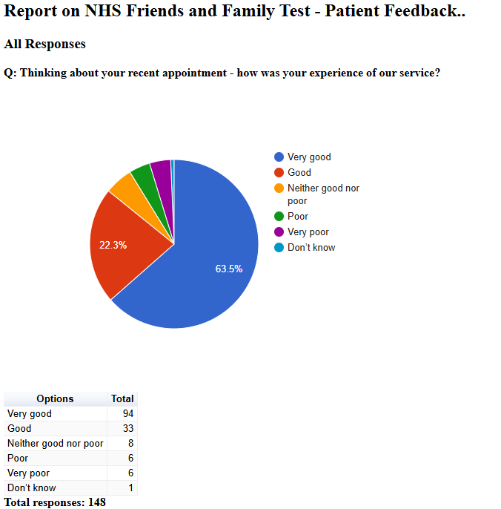

Friends and Family Admin

NHS Friends and Family Test - Patient Feedback

December 2024

NHS Friends and Family Test - Patient Feedback

All Responses

Q: Please tell us about anything that we could do better:
Free text question. There were 80 responses:
2024-12-03 11:06:30 View entire form
The environment is not very enabling for children, my daughter was okay but she was asking a lot of questions and it was very clinically. I understand it’s a hospital, but it would be nice if there was a bit more enabling environment for children
2024-12-09 12:05:05 View entire form
every thing was lovly
2024-12-09 12:15:37 View entire form
Down stairs appointment or a working lift very difficult with a 93 year old to negotiate steep stairs
2024-12-09 12:23:20 View entire form
more support lack of interest from doctor
2024-12-09 12:43:57 View entire form
Being more flexible with appointments e.g being able to make three monthly appointments.
2024-12-09 12:44:17 View entire form
Be able to make an appointment at the surgery and not turned away and told to ring up instead !!
2024-12-09 12:54:48 View entire form
Take on board more what patients say they know there bodies.
2024-12-09 12:59:20 View entire form
Made 24 phone calls from 8.30 onwards, just to speak to a nurse practitioner or a doctor, got through at dinner time, to be told all slots taken today ring tomorrow. Went personally next day got in straight away, that was very good
2024-12-09 13:09:38 View entire form
Every thing runs smoothly as it is
2024-12-09 13:09:43 View entire form
every onewas lovley
2024-12-09 13:11:02 View entire form
N/A
2024-12-09 13:11:10 View entire form
Sorting an appointment was somewhat more difficult than it should be however telephone operator was helpful and once appointed arranged all good. Appointment with nurse very good as was further appointment with physical therapist.
2024-12-09 13:11:33 View entire form
Could not understand why there wasn't any bandages for my legs
2024-12-09 13:12:37 View entire form
I did not receive the phone appointment I was promised. Got a text saying they had tried to call but I had no missed call on my phone. Said would call back before 4pm. No call. Now have to wait for next day off to call again. Job doesn’t make it easy to call.
2024-12-09 13:16:03 View entire form
See a GP quicker
2024-12-09 13:17:27 View entire form
Problem trying to make appointments
2024-12-09 13:19:25 View entire form
Nothing needed
2024-12-09 13:20:04 View entire form
The service offered is thoughtful, compassionate and joined up.
2024-12-09 13:23:52 View entire form
I was happy with my appointment
2024-12-09 13:26:13 View entire form
Friendliness of reception staff.
2024-12-09 13:28:31 View entire form
I had trouble booking in when I arrived at the Doctors and dint realise I hadn't been marked as arrived until the receptionist called me over
2024-12-09 13:58:07 View entire form
dr sabah jadoon is incredible! Just wanted to express deep gratitude for her.
2024-12-09 14:01:23 View entire form
The appointment went well and saw the nurse support a female and child to attend the appointment upstairs
2024-12-09 15:09:55 View entire form
Nothing
2024-12-09 15:11:26 View entire form
Get an appointment at my local surgery The Lanes! - 2 min walk from me.
2024-12-09 15:29:50 View entire form
Try & not tell patients they don't have a health condition when they have been informed by a specialist that they do. All your nursing team are lovely, minus one that should be dismissed regarding her professionalism. Usually have a good experience at Vernon Street & I appreciate everything the NHS does, but the last communication I recieved from a certain 'professional' was abysmal.
2024-12-09 15:58:27 View entire form
The doctor could look at me and actually appear to be listening instead of staring at the computer screen
2024-12-09 17:15:55 View entire form
Discrimination and low care regarding a very sensitive topic. No explanation at all about my questions. I would like to have another appointment with another GP.
2024-12-09 18:27:58 View entire form
Timing
2024-12-09 18:33:40 View entire form
She was good at Mickleover doctors, talk to her about sicknote after she took tests from me, l said am l allowed them she said ya many as you want, so not sure about lyn, does she know anything what I've got, seem to me she didn't like gave me lot sicknote out, last l had only 4 days that was including Saturday Sunday, mine sicknote didn't last out till 2nd but give me from 29th why gave me that last one was same as one before, so really had two sicknote same date. Wasn't really happy what sicknote I've had gaven, that short of sicknote wouldn't allow me put date in uc system
2024-12-09 18:51:50 View entire form
I can’t think of how you could improve on the perfect service I received from start to finish.
2024-12-10 11:32:09 View entire form
If I have to make an appointment it can be hard sometimes I know do ring back and this is better I think the staff at Vernon Street are very good
2024-12-12 07:28:46 View entire form
2024-12-13 05:19:27 View entire form

When I clearly explained I suffered the same before but I can’t remember the medication what they gave me last time. Didn’t bother to check and asked me to take antihistamine. I am still suffering from the same thing even after 7 days. No idea what to do or where to go.
2024-12-16 09:39:55 View entire form
Don't like telling my problems To receptionist it between me and my doctor
2024-12-16 11:09:18 View entire form
Appt v good but system of getting through on phone and securing appt difficult and quite traumatic.
2024-12-17 11:11:05 View entire form
I wasn’t given an estimated time for when the GP would contact me about my mental health appointment. Considering people can be busy, driving, at work, or in a public place, I hope the GP service can offer more flexibility.
2024-12-17 11:22:14 View entire form
Not possible to answer
2024-12-17 11:25:53 View entire form
All good
2024-12-17 11:31:34 View entire form
I felt heard and the practitioner was caring and empathetic.
2024-12-17 11:40:33 View entire form
Excellent. In all respect. Thanks
2024-12-17 11:59:13 View entire form
Let the patient know around the time the clinician is phoning, I.e am or pm
2024-12-17 12:08:43 View entire form
N/A
2024-12-17 12:20:38 View entire form
Nothing brilliant service
2024-12-17 12:28:53 View entire form
it’s very bad service, me and family came from a different country to serve the people here and paying tax and insurance as per the rule, but there is no appointments on time at GP, no needed investigation on time and no proper diagnosis and treatment on time, we need to suffer a very lot health wise which lead to so many sick leave, have to improve the GP Services a lot
2024-12-17 12:35:44 View entire form
explain prescriptions
2024-12-17 14:49:16 View entire form
Tried 3 times to see someone at the surgery. Twice sent to Osmaston road clinic and 3rd time a phone call.
2024-12-17 17:47:03 View entire form
Felt like the doctor was dismissing me or trying to convince me to do something i said i did not want to do
2024-12-18 12:49:14 View entire form
Appointments still a big problem
2024-12-18 15:25:47 View entire form
Appointments times could and should be better
2024-12-24 09:41:29 View entire form
The lady surgeon went beyond the call of duty to explain the pros and cons of polyps, and how best to move forward. 100 out of 100. My heartfelt thanks to the surgeon, NHS and Nye Bevan for bequeathing us this gift
2024-12-24 09:46:32 View entire form
On time. Treated with understanding
2024-12-24 10:01:58 View entire form
I have no complaints about the treatment I have received and would recommend this surgery if asked
2024-12-24 10:31:22 View entire form
Appointment booking system is really difficult. I work 8.30 to 5 and it's prohibitive to have to call first thing in the morning to arrange an appointment for that day as it clashes with work.
2024-12-24 10:46:13 View entire form
Very helpful and listened to me
2024-12-24 14:30:33 View entire form
Nothing at the moment as was pleased with the service.
2024-12-24 15:10:51 View entire form
I don't like the practicioners attitude. I feel that I have a far greater knowledge of my own medical history and that they do not respect that. This is the second occasion.
2024-12-24 15:50:18 View entire form
We were so pleased and relieved to get an appointment as we were feeling really unwell. Medication was prescribed and we continue to improve
2024-12-24 17:34:07 View entire form
Doctor Carson was really caring and has actually sent me for xrays and is properly investigating my problems
2024-12-24 20:16:17 View entire form
Follow up call, I got a text message with my results rather than a call explaining it
2024-12-27 20:50:22 View entire form
I had an accident in Nov 2024. I went to GP for checkup because I had pain in my neck. Doctor told me that it will be fine in few days and no medicine or exercise or therapy given to me. after two weeks i was still feeling pain as before. I book another appointment and went again to see Doctor at the lanes where Physiotherapist saw me. I told doctor that I have pain in my legs, she replied I have nothing do to with your leg. I can only talk about neck. I replied ok but right that I have pain in my leg, Doctor replied that no i will not right. After that she check my neck and asked me to move down I said I cannot move down my neck because of pain and she laughed on me like i am lieng. I feel so bad after seeing her laughing on me and not writing exactly what i told her. My experience with nhs is very bad frustrating and I feel that Nhs system is broken and totally failed
2024-12-27 23:54:00 View entire form
Well I'm confused as to how my tonsils are ok on checking my throat and given basal spray to clear chest and sinus when I had them out when I was 13

