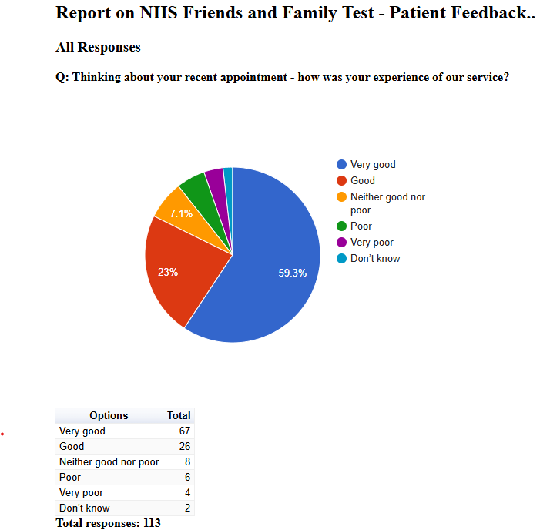

Friends and Family Admin

NHS Friends and Family Test - Patient Feedback

August 2024

All Responses

Q: Please tell us about anything that we could do better:
Free text question. There were 48 responses:
2024-08-05 08:38:26 View entire form
Not had an appoinment
2024-08-09 11:22:17 View entire form
N/a
2024-08-09 11:23:19 View entire form
Its diffecult when practice can't do anything with insulin medications for type q
2024-08-09 11:28:01 View entire form
Nothing really I was looked after all the time, even afterwards.
2024-08-09 11:31:06 View entire form
Actually do what you’re telling me. Still waiting for a call back which I’m obviously not going to get. Awful surgery, literally none of you have any idea about what your duty of care to your patients actually are.
2024-08-09 11:38:15 View entire form
There were some other symptoms I wanted to discuss regarding my problem but the doctor didn't have time so I didn't bother.
2024-08-09 12:00:59 View entire form
I think that allowances should be madefor patients travelling through road works etc. I was 10 mins late, & Gp couldn't see me.I had to go to a walk in clinic. Conversely, patients have to wait beside their phones hours to have a call back conversation with GP.
2024-08-09 12:11:30 View entire form
Excellent service.
2024-08-09 12:45:53 View entire form
Listening to the patient
2024-08-09 12:59:59 View entire form
As a new patient I am absolutely blown away by the excellent treatment I am receiving ! Dr Khalil, Debs the nurse and all reception staff have been amazing ! Thanks you all
2024-08-09 23:13:42 View entire form
Everything was appericiable. Specially the staff made us really comfortable.
2024-08-11 17:18:57 View entire form
On the whole good.
2024-08-12 11:49:09 View entire form
The doctor was very blunt and not empathetic
2024-08-12 11:56:18 View entire form
Free parking!!!!
2024-08-12 12:11:29 View entire form
Nothing excellent service
2024-08-12 12:13:03 View entire form
Make appointment earlier to access, I do understand that would be difficult
2024-08-12 12:18:21 View entire form
The dr didn’t listen to what I was saying and I’m struggling
2024-08-12 12:21:19 View entire form
Listened to.
2024-08-12 12:23:22 View entire form
Don't leave registrars on their own!
2024-08-12 12:27:49 View entire form
Link for photo upload useless on iPhone. Pop up prevented access to use the service.
2024-08-12 12:47:26 View entire form
My fourth visit and still no resolution of my ailment
2024-08-12 13:00:17 View entire form
I did send an email stating that I was unable to attend the appointment due to family issues
2024-08-12 13:10:22 View entire form
I sent a message to inform you that I was unable to attend the appointment but didn’t receive a teply
2024-08-12 13:14:18 View entire form
NA
2024-08-12 13:26:26 View entire form
Very kind and helpful dr and receptionist thank you
2024-08-12 14:27:31 View entire form
A better way of doing a blood test rather than waiting in A&E for hours.
2024-08-12 16:39:45 View entire form
- Rang at exactly 8.30 and it took over half an hour to get through… to be told there was no appointments. - Told I could only see a doctor at The Lanes which would cost be at least £20 in a taxi. I’m registered at Vernon Street, I expect to see a doctor at Vernon Street. - I specifically asked to see a doctor, and was assured my appointment was with a doctor. When I got there it was with a nurse. - I felt that I wasn’t listened to during my appointment and went away feeling very upset.
2024-08-12 17:13:29 View entire form
Find it difficult to make an appointment
2024-08-12 18:00:13 View entire form
It was booked as telephone, I arrived for F2F 20 MINS EARLY.
2024-08-13 02:01:01 View entire form
Nothing
2024-08-13 10:16:37 View entire form
If reception could take ownership and find out the query themselves rather than diverting me to call someone else to then have to call back reception to be in a long que. Especially when its a simple enquiry.
2024-08-13 10:28:51 View entire form
Nothing ! All staff are amazing and give excellent service and care especially Dr.Khalil, nurse Debs and All reception staff
2024-08-13 10:43:24 View entire form
I had other things to discuss but you only 1 appointment to discuss one problem
2024-08-13 10:46:10 View entire form
No message left to say you called. Registrars not knowledgeable enough. Follow up up appointments not actioned. Poor excuses as to why they're not followed up. eg "erm sometimes it happens". Too long to answer the phone
2024-08-13 10:50:21 View entire form
Every thing was great Dr Jadoon was understanding and helpful
2024-08-13 11:00:49 View entire form
EVERYTHING ABOUT THE APPOINTMENT WAS VERY GOOD FROM START TO FINISH IT COULD NOT HAVE BEEN BETTER FROM RECEPTIONIST TO THE DOCTOR WAS VERY GOOD INDEED DON'T CHANGE A THING 10 OUT OF 10.
2024-08-13 13:24:16 View entire form
Whilst a decision of no further action after blood test results where results outside nhs guidelines then a face-to-face explanation should be the norm if no communication is given how can we believe in the process is robust .
2024-08-13 13:52:45 View entire form
Greetings of the day! www.vernonstreetandthelanes.co.uk I was reviewing your website and would like to know if you are looking for any website re-design or revamp. We are experienced developers and have expertise to design & develop a professional website for the end user or customer service. Please let me know if you are interested and looking for a website or maybe a web software for your business. Warm regards, Sam Morris (Web Solution Manager) If you don’t want me to contact you again about this, reply with “Opt-Out”
2024-08-13 14:17:54 View entire form
I expected to be examined instead the doctor was on his computer looking things up.
2024-08-13 14:32:23 View entire form
I find this practice exceptional. Only thing.....maybe some air conditioning upstairs on hot days!
2024-08-13 19:24:50 View entire form
Pre bookable appt took over a week to get
2024-08-15 14:16:20 View entire form
It was a telephone conversation about a blood result. The only thing that could have been better is to have reassurance before hand. I had a text to say an appointment had been made for me to discus the results of the blood test. The appointment was a week away. I’m a worrier and was scared about what the result was.
2024-08-19 10:54:09 View entire form
On this occasion all was fine but this has not been my experience since pre-Covid lockdown. The Vernon Street and the Lanes was an excellent GP Practice but changed, possibly reflecting changes across the country.
2024-08-20 20:14:35 View entire form
Have appointment at nearest surgery
2024-08-22 13:40:19 View entire form
I was kept waiting 25 minutes beyond my appointment time and all the while was subject to pop music at too loud a level with no chance of moving away from it as the waiting room is not large . I didn't go in with a headache but I came out with one
2024-08-29 07:34:47 View entire form
Having more appointments ready
2024-08-29 14:06:59 View entire form
I have made four visits to the surgery recently and seen three different doctors non of whom has given me a cause of the pain that I am suffering.

