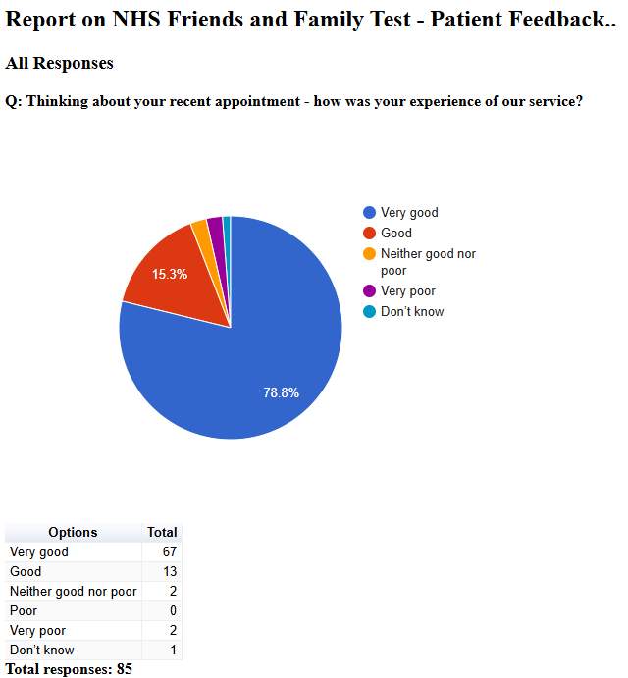

Friends and Family Admin

NHS Friends and Family Test - Patient Feedback

April 2025
2025-04-10 13:17:17 View entire form
No improvements required
2025-04-10 14:03:07 View entire form
The appointment was good. No follow up on urine test results.
2025-04-10 14:30:01 View entire form
Employ the gp who I saw full time
2025-04-10 14:34:15 View entire form
Nothing always great service.
2025-04-10 14:45:23 View entire form
Amazing always welcoming and kind and helpful
2025-04-10 15:48:28 View entire form
Note
2025-04-10 16:04:31 View entire form
Not really
2025-04-10 16:28:38 View entire form
Nothing. I love this surgery
2025-04-10 16:29:23 View entire form
Excellent service. Carry on the good work
2025-04-10 16:41:57 View entire form
Nothing comes to mind as I always have a very positive experience. All staff are professional and extremely helpful.
2025-04-10 17:03:15 View entire form
Turn the radio down in waiting room
2025-04-10 17:51:45 View entire form
Answer the phone quickly
2025-04-10 18:48:43 View entire form
Nothing
2025-04-10 19:49:25 View entire form
Have more appointments available in advanceand on the day
2025-04-11 06:49:18 View entire form
Couldn't do better
2025-04-11 08:26:10 View entire form
Nothing could have been done any better
2025-04-11 08:51:24 View entire form
Staff were timely, responded in a pleasant and professional manner
2025-04-11 13:26:05 View entire form
Your service to me does not warrant any improvement thank you
2025-04-13 07:09:00 View entire form
Nothing
2025-04-14 09:51:41 View entire form
Struggled to get appointment, had to pre book.and wait a couple of weeks, bit the service I got from the doctor was excellent, he arranged , physio straight away, 2025-04-23 15:54:59 View entire form
The doctor I seen introduced himself as Mike was wearing a hoodie, and obviously pre judged me, without an examination, he told me my back problems which have already been diagnosed as a degenerative condition, was just wear and tear, and was mind over matter.. and when I replied that he was full of it..he said I was aggressive and asked me to leave..
2025-04-23 16:25:21 View entire form
Everything excellent thank you
2025-04-23 16:25:21 View entire form
Everything excellent thank you
2025-04-23 16:30:43 View entire form
I was happy with the service
2025-04-23 16:33:32 View entire form
Nothing
2025-04-23 16:35:52 View entire form
GP availability of appointments
2025-04-23 16:36:07 View entire form
I had an appointment with Dr Sabir. I normally see him now if I can for continuity . He is the best doctor I have ever had, he is professional whilst being compassionate and empathetic. it’s all because of him a serious heart condition has been diagnosed. I cannot speak highly enough of him and please thank him for his amazing service and supporting my husband and I who are both his patients throu what is a very difficult time at the moment . 5 stars for Dr Sabir
2025-04-23 16:46:14 View entire form
Very pleased with everything from the practice, no negatives at all.
2025-04-23 17:06:39 View entire form
I've not had a appointment despite trying since February
2025-04-23 17:55:55 View entire form
Nothing.
2025-04-23 18:09:21 View entire form
It was a scheduled appointment and I was seen on time and my problem addressed and explained!
2025-04-23 18:15:14 View entire form
Blood tests And Blood pressures as was done Previously. So helpful thank you
2025-04-23 18:35:51 View entire form
No very happy
2025-04-23 18:54:30 View entire form
As I had requested to see a female GP, I, unfortunately, had to wait 5 weeks for an appointment.
2025-04-23 19:09:32 View entire form
Well done
2025-04-23 19:13:10 View entire form
Excellent
2025-04-24 00:05:46 View entire form
You asked me to review an appointment, but I never had it. The GP was off sick, and I missed a random phone call so never spoke to anyone. I never asked for an appointment, but I think this was one of those 'chedk if I'm dead' phone calls haha. I'm not, so that's good.
2025-04-24 23:56:46 View entire form
Nothing
2025-04-30 16:18:52 View entire form
Nothimg
2025-04-30 17:15:22 View entire form
Absolutely nothing. Fantastic surgery fantastic office staff fantastic doctors

referral to make, and pain relief.

